**CHAPTER2 EXERCISE**

**1.Write a C program to accept two integers and check whether they are equal or not.**

#include<stdio.h>

int main()

{

int num1, num2;

printf("Enter The First Number:");

scanf("%d",&num1);

printf("Enter The Second Number:");

scanf("%d",&num2);

if(num1== num2)

{

printf("Two Numbers are Equals");

}

else

{

printf("Two Numbers are Not Equals");

}

return 0;

}

Output: 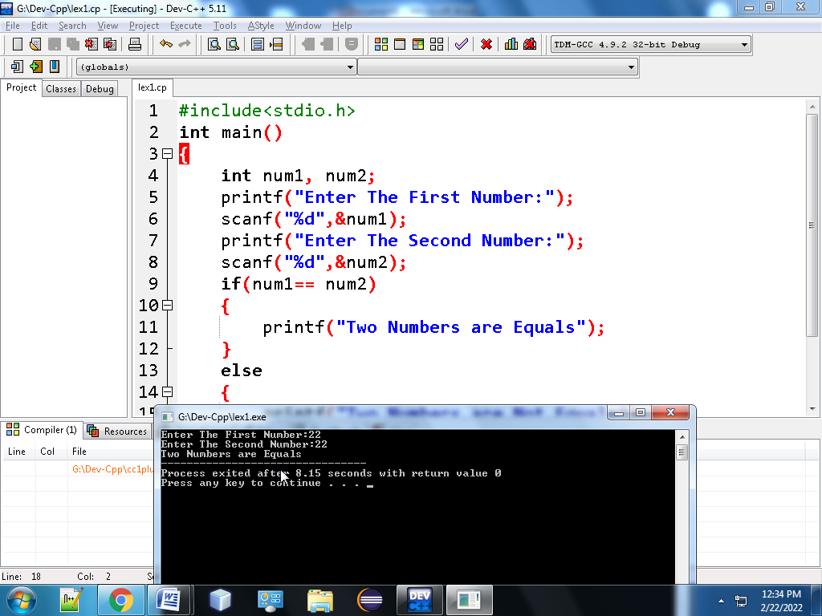

**2. Write a C program to check whether a given number is even or odd.**

#include<stdio.h>

int main()

{

int n;

printf("Enter The Number to Find Odd or Even:");

scanf("%d",&n);

if(n%2==0)

{

printf("The Given Number is Even Number");

}

else

{

printf("The Given Number is Odd Number");

}

return 0;

}

output:

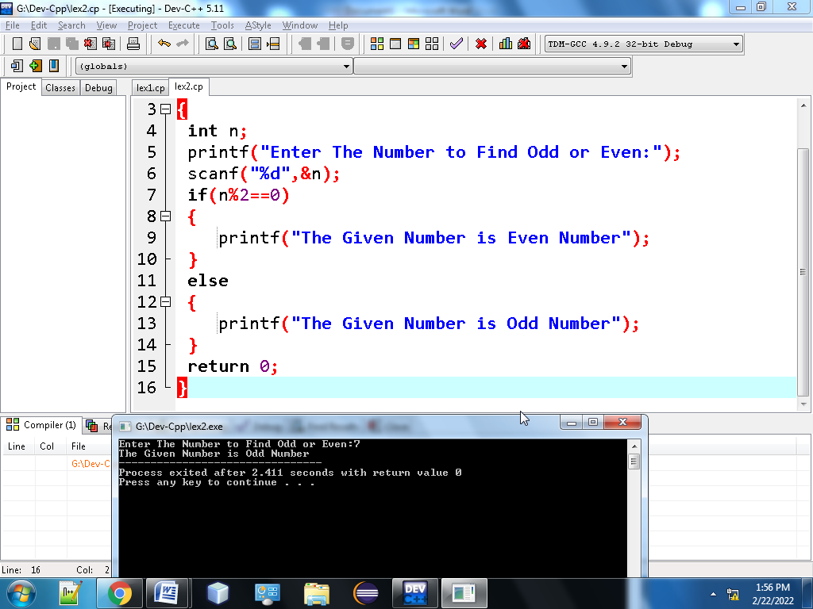

**3. Write a C program to check whether a given number is positive or negative**

#include<stdio.h>

int main()

{

int a;

printf("Enter The Number To Find Positive or Negative Number:");

scanf("%d",&a);

if(a>0)

{

printf("Given Number is Positive Number");

}

else if(a<0)

{

printf("Given Number is Negative Number");

}

else

{

printf("The Given Number is Neutral Number");

}

return 0;

}

Output:

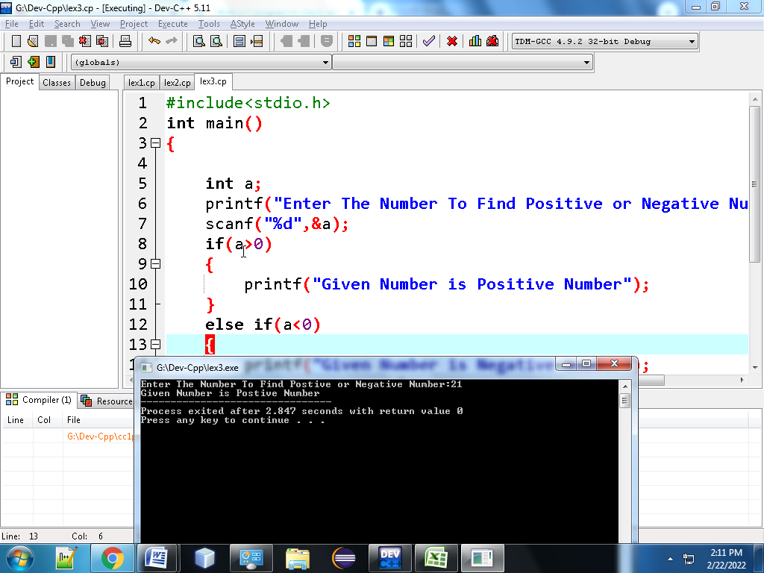

4) **Write a C program to find whether a given year is a leap year or not.**

#include <stdio.h>

int main() {

int year;

printf("Enter a year: ");

scanf("%d", &year);

if (year % 400 == 0) {

printf("%d is a leap year.", year);

}

else if (year % 100 == 0) {

printf("%d is not a leap year.", year);

}

else if (year % 4 == 0) {

printf("%d is a leap year.", year);

}

else {

printf("%d is not a leap year.", year);

}

return 0;

}

Ouput:

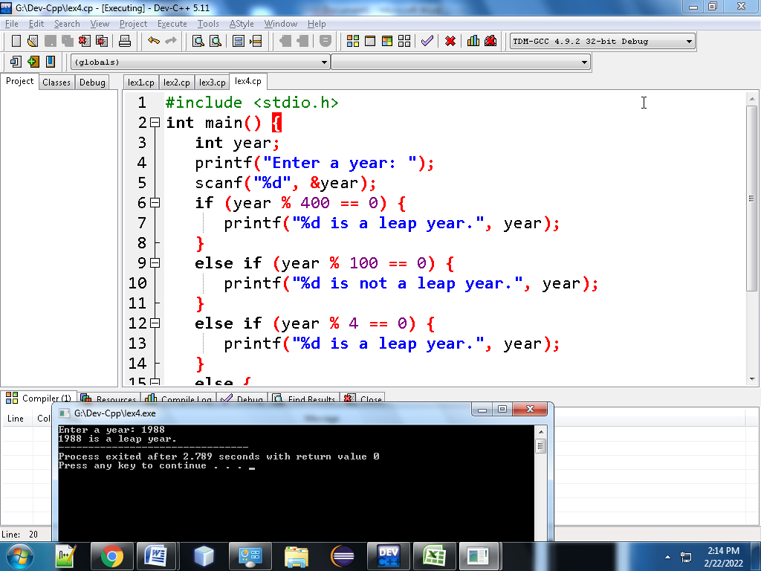

**5.Write a C program to read the age of a candidate and determine whether it is eligible for casting his/her own vote.**

#include<stdio.h>

int main()

{

int age;

printf("Enter Your age:");

scanf("%d",&age);

if(age>=18)

{

printf("You are Eligible to vote");

}

else

{

printf("You are Not Eligible to vote");

}

return 0;

}

OUTPUT

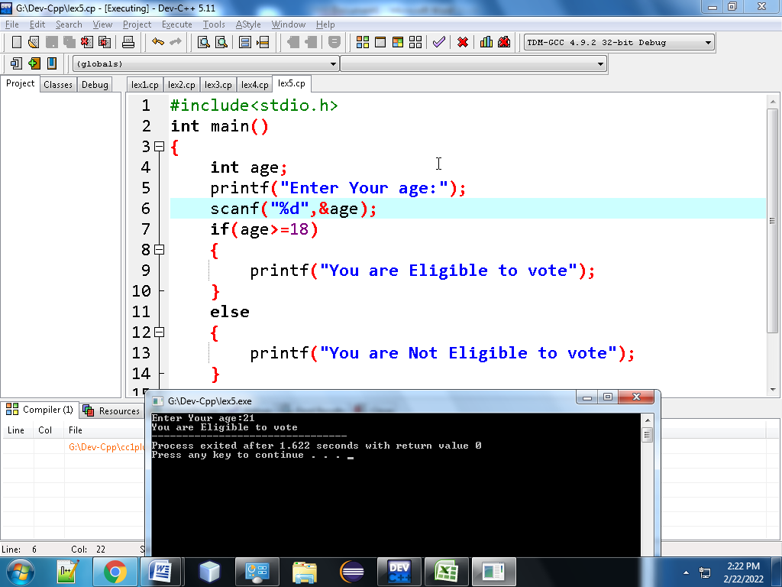

**6. Write a C program to read the value of an integer m and display the value of n is 1 when m is larger than 0, 0 when m is 0 and -1 when m is less than 0.**

#include <stdio.h>

int main()

{

int m,n;

printf("Input the value of m :");

scanf("%d",&m);

if(m!=0)

{

if(m>0)

{

n=1;

}

else

{

n=-1;

}

}

else

{

n=0;

}

printf("The value of m = %d \n",m);

printf("The value of n = %d \n",n);

}

Ouput:

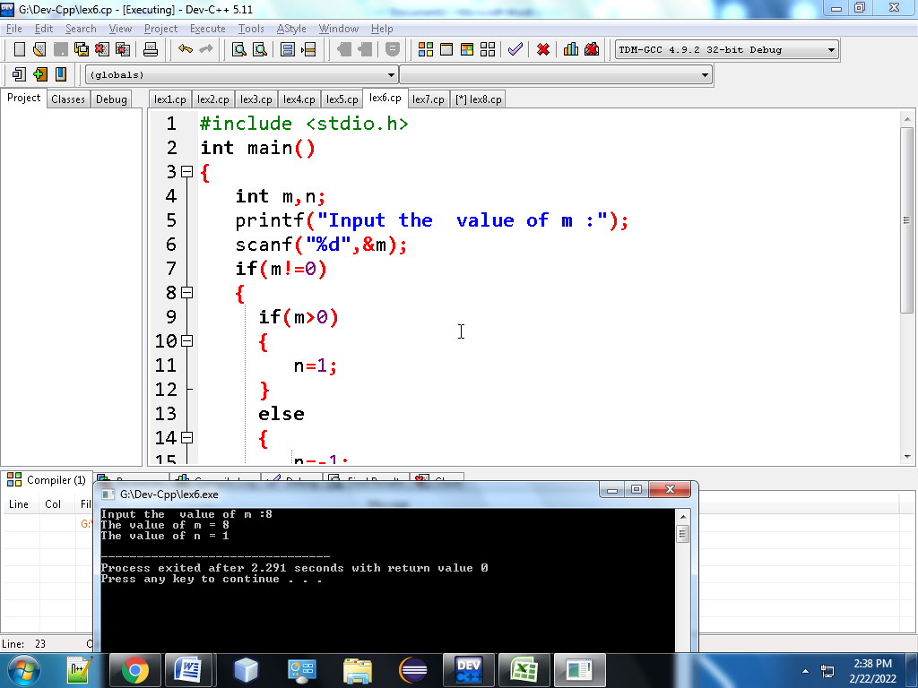

7) **Write a C program to accept the height of a person in centimeter and categorize the person according to their height.**

#include <stdio.h>

int main()

{

float PerHeight;

printf("Input the height of the person (in centimetres) :");

scanf("%f", &PerHeight);

if (PerHeight < 150.0)

printf("The person is Dwarf. \n");

else if ((PerHeight >= 150.0) && (PerHeight < 165.0))

printf("The person is average heighted. \n");

else if ((PerHeight >= 165.0) && (PerHeight <= 195.0))

printf("The person is taller. \n");

else

printf("Abnormal height.\n");

return 0;

}

Output:

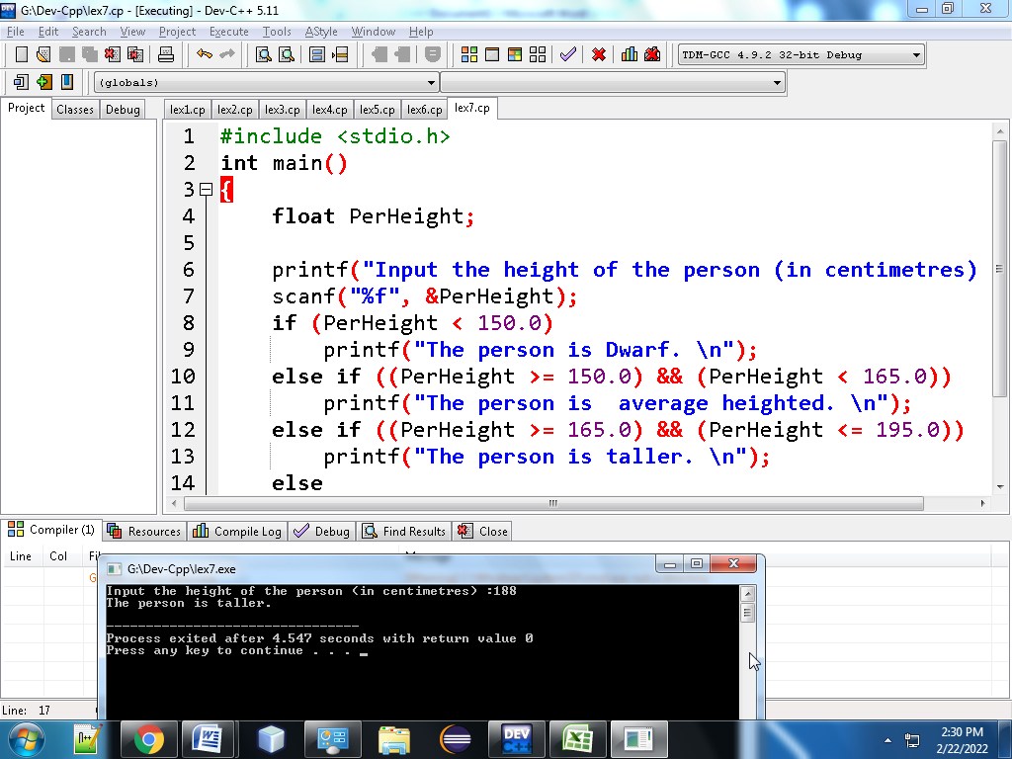

8.**Write a C program to find the largest of three numbers.**

**#include <stdio.h>**

**int main()**

**{**

**int n1, n2, n3;**

**printf("Enter three numbers: ");**

**scanf("%d %d %d", &n1, &n2, &n3);**

**if (n1 >= n2 && n1 >= n3)**

**{**

**printf("%d is the largest number.", n1);**

**}**

**else if (n2 >= n1 && n2 >= n3)**

**{**

**printf("%d is the largest number.", n2);**

**}**

**else**

**{**

**printf("%d is the largest number.", n3);**

**}**

**return 0;**

**}**

**Output:**

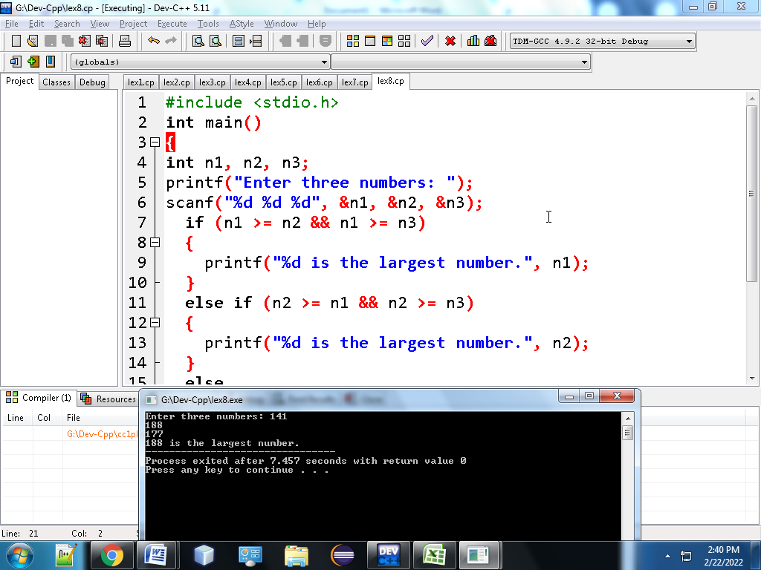

**9. Write a C program to accept a coordinate point in a XY coordinate system and determine in which quadrant the coordinate point lies**

**#include <stdio.h>**

**int main()**

**{**

**int co1,co2;**

**printf("Input the values for X and Y coordinate : ");**

**scanf("%d %d",&co1,&co2);**

**if( co1 > 0 && co2 > 0)**

**{**

**printf("The coordinate point (%d,%d) lies in the First quandrant.\n",co1,co2);**

**}**

**else if( co1 < 0 && co2 > 0)**

**{**

**printf("The coordinate point (%d,%d) lies in the Second quandrant.\n",co1,co2);**

**}**

**else if( co1 < 0 && co2 < 0)**

**{**

**printf("The coordinate point (%d, %d) lies in the Third quandrant.\n",co1,co2);**

**}**

**else if( co1 > 0 && co2 < 0)**

**{**

**printf("The coordinate point (%d,%d) lies in the Fourth quandrant.\n",co1,co2);**

**}**

**else if( co1 == 0 && co2 == 0)**

**{**

**printf("The coordinate point (%d,%d) lies at the origin.\n",co1,co2);**

**}**

**return 0;**

**}**

**Ouput:**

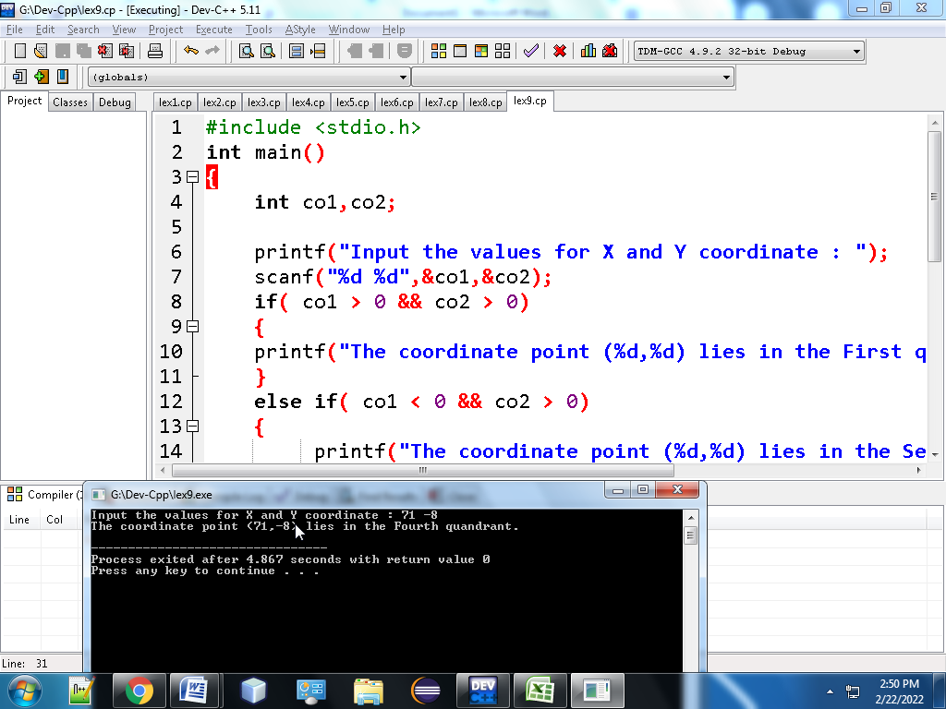

**10. Write a C program to read roll no, name and marks of three subjects and calculate the total, percentage and division.**

**#include <stdio.h>**

**#include <string.h>**

**int main()**

**{**

**int rl,phy,che,ca,total;**

**float per;**

**char nm[20],div[10];**

**printf("Input the Roll Number of the student :");**

**scanf("%d",&rl);**

**printf("Input the Name of the Student :");**

**scanf("%s",nm);**

**printf("Input the marks of Physics, Chemistry and Computer Application : ");**

**scanf("%d%d%d",&phy,&che,&ca);**

**total = phy+che+ca;**

**per = total/3.0;**

**if (per>=60)**

**{**

**strcpy(div,"First");**

**}**

**else if (per<60&&per>=48)**

**{**

**strcpy(div,"Second");**

**}**

**else if (per<48&&per>=36)**

**{**

**strcpy(div,"Pass");**

**}**

**else**

**{**

**strcpy(div,"Fail");**

**}**

**printf("\nRoll No : %d\nName of Student : %s\n",rl,nm);**

**printf("Marks in Physics : %d\nMarks in Chemistry : %d\nMarks in Computer Application : %d\n",phy,che,ca);**

**printf("Total Marks = %d\nPercentage = %f\nDivision = %s\n",total,per,div);**

**return 0;**

**}**

Ouput:

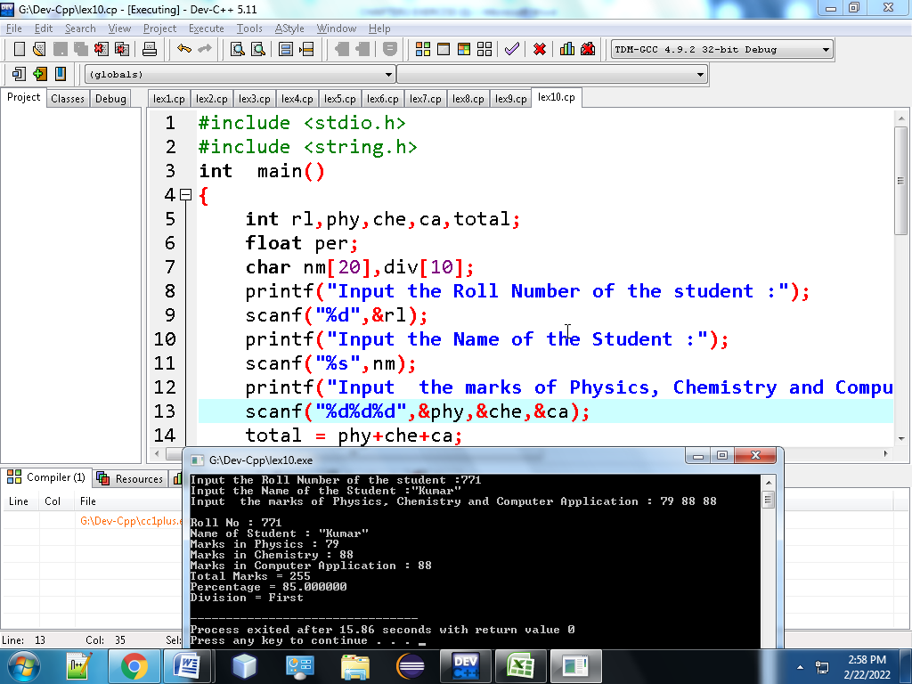

**11. Write a C program to check whether a triangle is Equilateral, Isosceles or Scalene.**

#include<stdio.h>

int main()

{

int side1, side2, side3;

printf("Enter sides of triangle:");

scanf("%d%d%d",&side1,&side2,&side3);

if(side1 == side2 && side2 == side3)

{

printf("The Triangle is equilateral\n");

}

else if(side1 == side2 || side2 == side3 || side3 == side1)

{

printf("The Triangle is isosceles\n");

}

else

{

printf("The Triangle is scalene\n");

}

return 0;

}

Ouput:

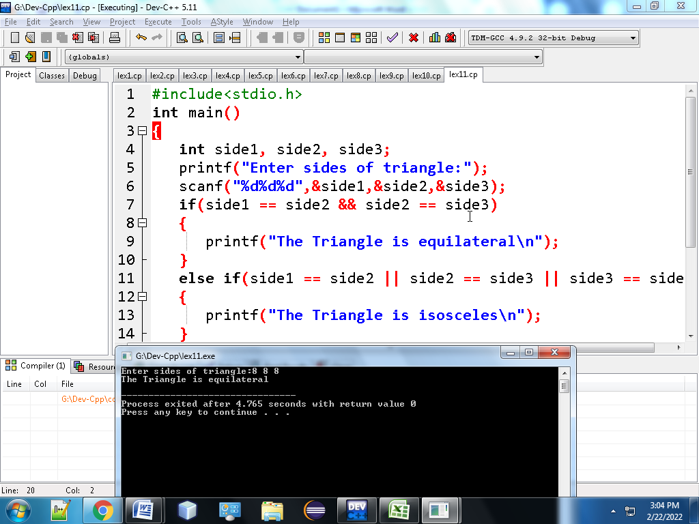

**12. Write a C program to check whether a triangle can be formed by the given value for the angles**

#include <stdio.h>

int main()

{

int anga, angb, angc, sum;

printf("Input three angles of triangle : ");

scanf("%d %d %d", &anga, &angb, &angc);

sum = anga + angb + angc;

if(sum == 180)

{

printf("The triangle is valid.\n");

}

else

{

printf("The triangle is not valid.\n");

}

return 0;

}

Output:

